How to Set Up OD Web Service

Introduction 1
Requirements 1
Procedure 2
Unzip the Web Service Folder 2
Set Folder Permissions 2
Register the Service 7
Edit Web.Config 8
Edit BasicData.htm 9
Configure Web Application in IIS Manager 10
Test the Application 14

Introduction
The CUAHSI Observations Data Model (ODM) is a schema for storing hydrologic observations time series data. Scientists apply the schema to create an Observations Database (OD) for their data. To assist scientists in publishing their OD data, CUAHSI has developed an OD web service. This document explains how to install and configure an OD web service for your OD.

Requirements
Hardware:
- HIS Server Appliance

Software:
- Micosoft Windows XP or 2003
- IIS with ASP.Net
- .Net 2.0 Framework
- Msbuild installed (.Net 2.0 Framework SDK, or Visual Studio installation)
- SqlServer Express, or SQL Server Database that service can connect to

Data:
- Observations Database (.mdf file)
- GenericODws_Release_1_1.zip file containing Generic OD web service support files (from CUAHSI). GenericODws.zip contains a sample OD.mdf database for testing purposes.

Personnel:
- User with administrator account

Procedure
This section describes the steps required to set up the service. Multiple services can be configured, we utilize a tool, msbuild, which is included with the .Net framework SDK or a Visual Studio install. If you only want a single service, an msi based installed is available.
For the advanced user, each section begins with a description of what is being done. If you understand the description, you may proceed on your own. For users who need more information than the short description, step-by-step instructions follow the description.

Note: If you have more than one OD, you’ll have to set up a separate OD web service for each database.

Unzip the Web Service Folder
First you’ll unzip the web service folder to the IIS folder, and give it a name appropriate for your database.

- Unzip GenericODws_Release_1_1.zip to a directory, eg: D:\HIS\GenericODWS\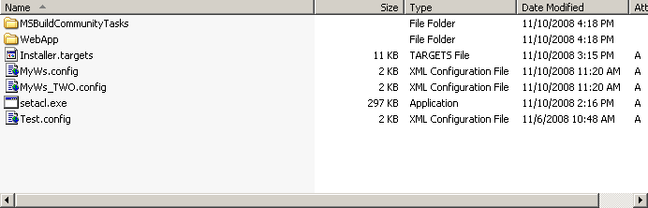

Create a new service configuration
The install process uses a configuration file. You will now create a copy, and edit the file to set the parmeters required.
Copy the file MyWS.config, to MyService.config
MyService.config has three sections, connectionStrings (database information), appsettings (settings for your web service), and install (information about your installation). Now edit the MyService.config for the service to give your service a network name and vocabulary, and specify the connection string to your database.

- In the folder for your web service, locate the MyService.config file, and edit it.

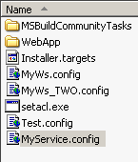

Note: I’ve used Visual Studio 2005 as my editor in these screenshots.

- In MyService.config, set the network and vocabulary for your service by editing the appropriate <add> elements. The network refers to the observation network to which your database pertains, such as “NWIS Daily Streamflow”. The vocabulary refers to the framework within which the terms that you use apply, such as “NWIS”. You can leave these as the default value of “ODM” if you wish. The “GetValuesName” can be used by applications as hint of what to call your network in a menu. It should be a brief name (<25 characters).

<add key="contactEmail" value="ws@example.com" />
<add key="network" value="UNDEFINED_NETWORK" />
<add key="vocabulary" value="UNDEFINED_VOCABULARY" />
<add key="SeriesName" value="My Test WS" />
<add key="ServiceDescriptionPage" value="BasicData.htm" />

- Edit the connection string for your database. To find the connection string, location the <connectionStrings> element. Then find the <add> element that is a child of <connectionStrings>, which has a name of “ODDB”. This element has an attribute called “connectionString”, which you will edit as follows:
  - If database is inside the App_data folder:

<add name="ODDB"
connectionString="Data Source=.\SQLEXPRESS;
Integrated Security=true;
User Instance=true;
AttachDbFilename=|DataDirectory|[FILENAME];
Database=[DATABSE_NAME]" providerName="System.Data.SqlClient"/>

  - If database is a local file:

<add name="ODDB" connectionString="Data Source=.\SQLEXPRESS;
Integrated Security=true;
User Instance=true;
AttachDbFilename=[PATH_TO_FILE][FILENAME];
Database=[DATABSE_NAME]" providerName="System.Data.SqlClient"/>

  - If database is a local database:

<add name="ODDB" connectionString="Data Source=.\SQLEXPRESS;
Integrated Security=true;
Database=[DATABSE_NAME]" providerName="System.Data.SqlClient"/>

  - If database is remote:

<add name="ODDB" connectionString="Data Source=[HOSTNAME];
Integrated Security=true;
Database=[DATABSE_NAME]" providerName="System.Data.SqlClient"/>

Note: In the connection string, replace the items in brackets with your actual items (do not include the brackets):
- [HOSTNAME] – the computer’s name hosting the database, e.g., DatabaseComputer
- [DATABASE_NAME] – e.g., MyOD
- [PATH_TO_FILE] – e.g., c:\Databases\
- [FILENAME] – e.g., MyDatabase.mdf

- Edit the <Install>. You should change the <VirtualDirectory> element, as this will be the name of the web service. In the example below, http://localhost/ODWSv11
<VirtualDirectory>ODWSv11</VirtualDirectory>
<!-- web app will be depoyed to $(DeploymentFolder)\$(VirtualDirectory) -->
<DeploymentFolder>.\virtualdirectories\</DeploymentFolder>
The web application will be installed under the directory where the service is located. If you want to install the application in a different location, eg under the standard web server IIS\www, then you can change <DeploymentFolder>.
- Save and close MyService.config

Edit BasicData.htm
BasicData.htm is appended to the web service description page when that page is viewed with an Internet browser. BasicData.htm gives information about your service, such as example parameters that can be used for testing the service. Edit this page to describe your service and data.

- Edit BasicData.htm. You may put whatever content you like in this file.
- Save and close BasicData.htm.

As an example, I edited BasicData.htm to show how to retrieve data from the sample OD.mdf database included with GenericODws.zip.

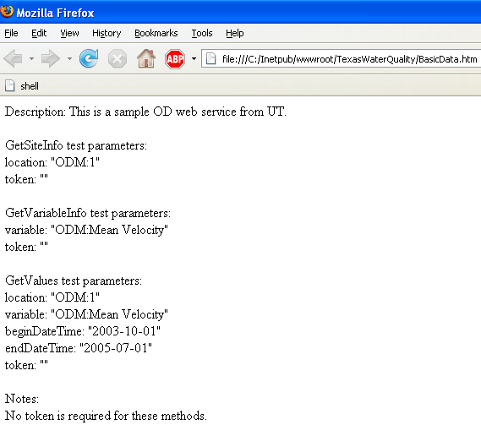

Install using MS Build
In this step you will install the application by opening a command line, change to the directory, and running the msbuild file.
- Open a command line for the .Net SDK (2.0 or higher), or Visual Studio
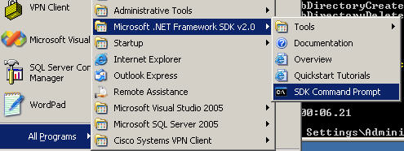 .NET SDK
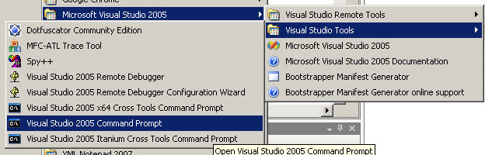 Visual Studio
- Change to the drive and directory;
C:
Cd \HIS\GenericODWS
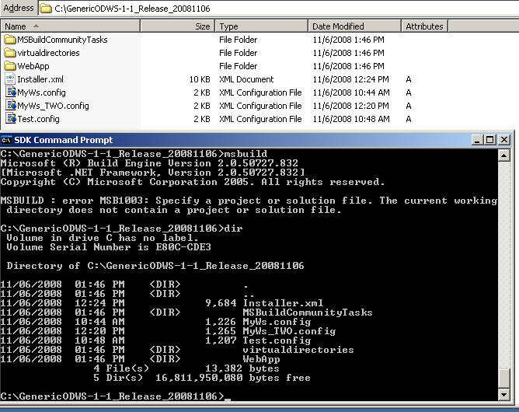
- Run msbuild.
msbuild Installer.targets /t:Install /p:Environment=[SERVICE CONFIG WITOUT THE CONFIG]
eg
msbuild Installer.targets /t:Install /p:Environment=MyService
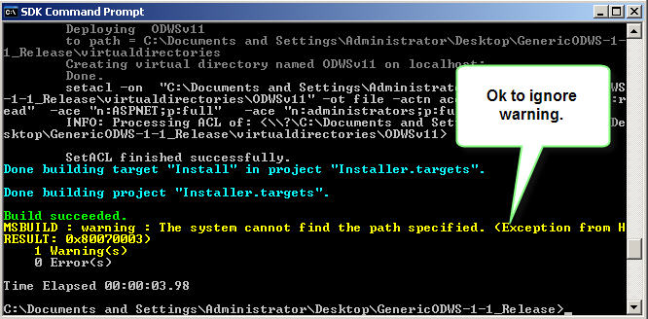

Confirm the installation of the Web Application using IIS Manager
In IIS Manager, you will now create a

- Open IIS Manager by clicking Start→Control Panel→Administrative Tools→Internet Information Services.

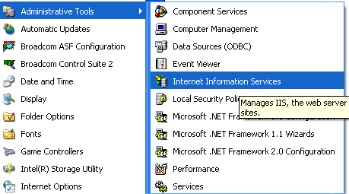

- Navigate to Web Sites→Default Web Site→[Your Web Service Folder Name].
- Right click on your folder and click Properties.

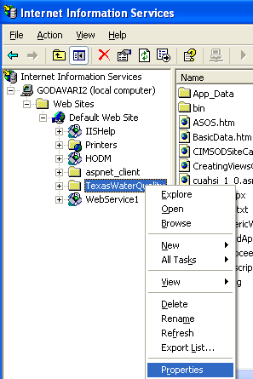

- Click the Directory tab. It should have an application name, execute permissions.

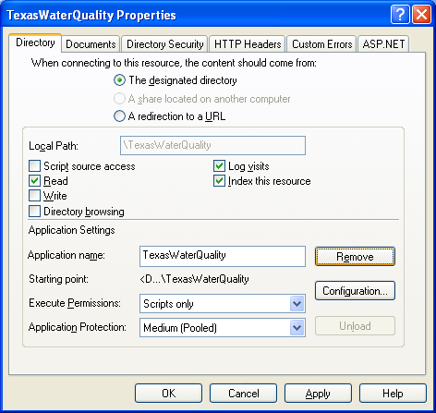

- Click the ASP.NET tab. Make sure the ASP.NET version is 2 or higher.

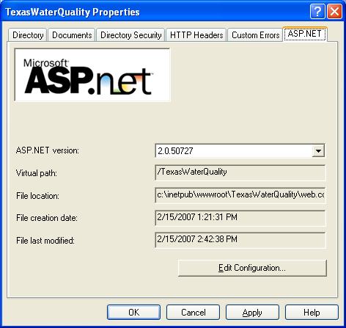

- Click OK.
- Close IIS.

Test the Application
Now you’re ready to test the application. Open a browser, and navigate to your localhost\[Service] folder, and invoke some calls for testing.

- Open an Internet browser.
- In the address bar of the browser, enter the following address:

http://localhost/[FOLDER NAME FOR YOUR SERVICE]/

- Input test parameters and see if your service works.

APPENDIX:

(Advanced-Optional)Configure logging
Logging uses a codebase called log4net (http://logging.apache.org/log4net/). There are two logs created, 1) a query log (log-data\query-log.txt), and 2) webapp-log.txt. The query-log.txt contains details on the queries, and webapp-log.txt can contain detailed debug information.
- Server logs are configured to send data to SDSC and write local error information to a directory called log-data. If this directory is not writable or present, then no local error information will be available.
To change, open “wateroneflow.logging.log4net” edit the
<appender name="QueryLogFileAppender" type="log4net.Appender.RollingFileAppender">
<file value="log-data\query-log.txt" />
<!-.. ->
</appender>

Troubleshooting.
Often the issues are with connection strings or folder permissions,

Manually Set Folder Permissions
You must set permissions for the folder so that the appropriate accounts have enough control to make the service work. The permissions you are setting are:

- [Your Service Folder]: Everyone - Read
- [Your Service Folder]: ASPNET - Full Control
- [Your Service Folder]\App_Data: Network_Service - Full Control

- In Windows Explorer, right click on the web service folder, and click Sharing and Security.

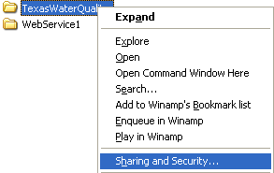

- Click the Security tab.

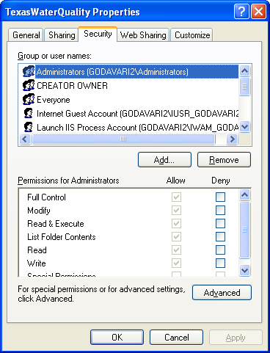

- Set the following permissions:
  - Everyone - Read
  - ASPNET - Full Control

If you did not see the group or user name for the above permissions, you will need to add that permission. Steps 4-11 walk you through that process. Otherwise, skip to step 12.

- Click Add.
- In the Select Users, Computers, or Groups window, click Advanced.

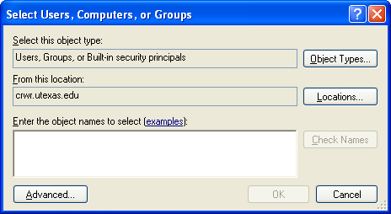

- In the window that opens, click Locations.
- In the window that opens, select your computer, and then click OK.

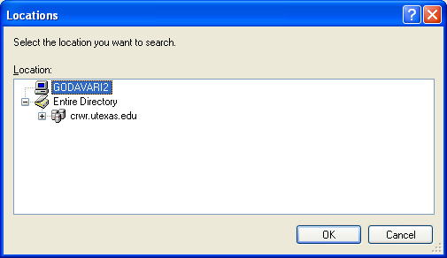

- Click Find Now.
- Scroll to the desired name, highlight it by left clicking on it, and click OK.

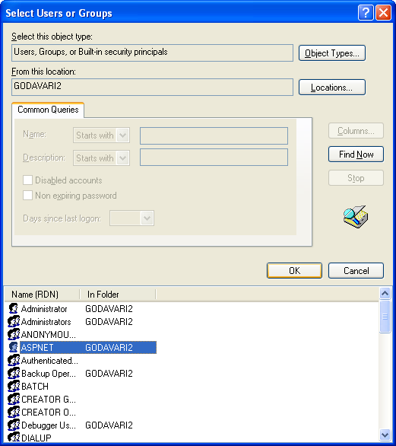

- Click OK to confirm the user name.

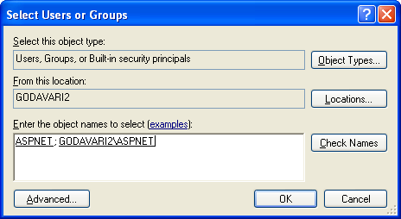

- Set the permissions, and then click Add if there are remaining user names that you need to add.

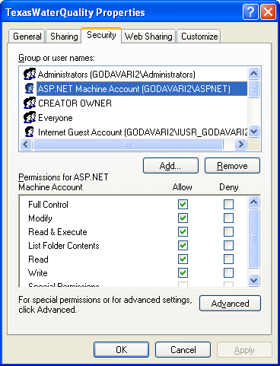

- Click OK to close the Properties window for your folder.
- Within your web service folder, navigate to the App_Data folder.
- In the same manner as above, set permissions for the App_Data folder as follows:
  - Network_Service - Full Control

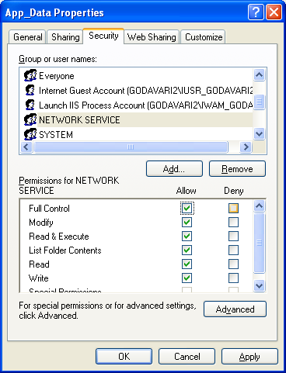

- Click OK to close the Properties window.

